Physical Science Study Guide – Test #4Solutions, Acids and Bases
I. Solutions
Match the Definitions with the correct vocabulary terms.
_____1. Solute a. a type of mixture that is the same throughout.
_____2. Solvent b. part of a solution that gets dissolved.
_____3. Solution c. part of solution that does the dissolving.
_____4. concentrated d. when there is a high amount of solute in a solution.
_____5. electrolyte e. a substance that conducts electricity when dissolved in water
_____6. Acid f. a substance that produces OH-ions when dissolved in solution
_____7. Base g. a substance that produces H+ ions in solution
_____8. Indicator h. a substance that changes color in the presence of an acid or base
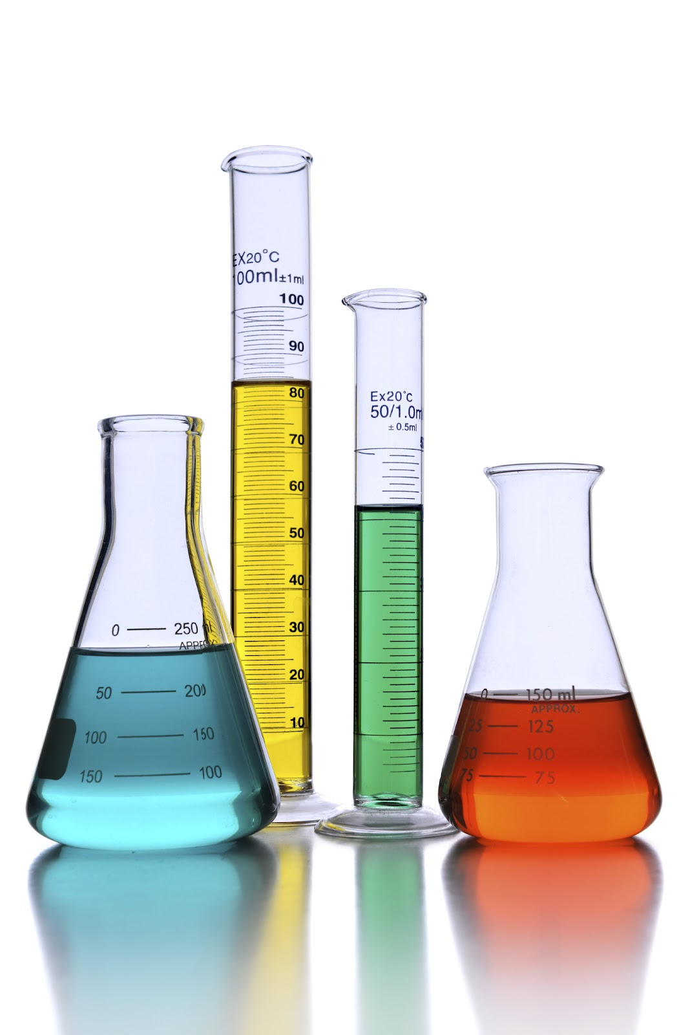
_____9. Neutral i. substance that has the same numbers of H+ and OH- ions in solution
- In a mixture of sugar and water, what part is the solute? What is the solvent?
- What can you do to increase the rate of dissolving?
a. stir b. crush the solute c. heat the solvent d. all of the above
- What is solubility?
- What type of solution contains a greater concentration of the solute; a concentrated solution or a dilute solution?
- Explain saturated, unsaturated, and supersaturated solutions.
- When dissolving a gas in a liquid, would you be able to dissolve more gas in a cold liquid or warm?

- What type of solute would conduct electricity when dissolved; electrolytes or nonelectrolytes?
- How do solute particles affect the freezing point and the boiling point of the solvent?

Multiple Choice Practice – For each of the following, write the letter of the term or phrase that best completes the sentence or answers the question.

______ 1. In a solution, the substance that is being dissolved is the _____________.
a. solute b. solvent c. liquid d. gas

______ 2. The air that you breathe is an example of a(n) _______________ solution.
a. gaseous b. solid c. liquid d. alloy

______ 3. In a Coca Cola, the solvent would be the ___________________.
a. water b. carbon dioxide c. sugar d. flavoring

______ 4. A substance that does not conduct an electric current when it forms a
solution is a(n) __________________.
a. electrolyte b. nonelectrolyte c. polar substance d. salt

______ 5. A solution that contains all of the solute it can normally hold at a given
temperature is ____________________.
a. dilute b. unsaturated c. supersaturated d. saturated

______ 6. Increasing the surface area or crushing a solid ___________________________.
a. slows the speed of dissolving c. increases the speed of dissolving
b. has no effect on the speed of dissolving d. causes the solid to ionize

______ 7. The concentration of a solution that contains a large amount of solute in the
solvent could be described as _________________________.
a. unsaturated b. polar c. concentrated d. dilute

______ 8. Adding more solute to a solvent _____________________.
a. raises its freezing point c. raises its boiling point
b. lowers its boiling point d. does not affect its boiling point

______9. Which of the following will the increase the dissolving of a solid solute in
water?
a. stir the solution c. grind up the solvent
b. cool the solution d. freeze the solute
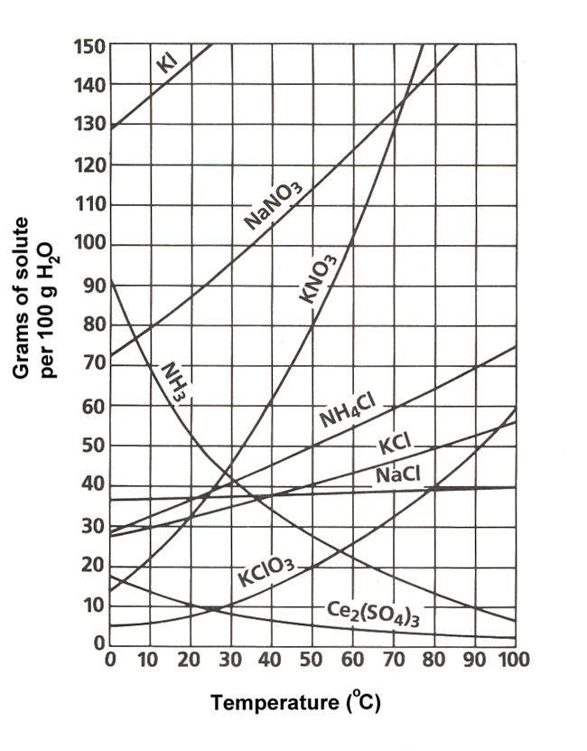
Solubility Curve

10. Based on the graph above, how much SO₂ will dissolve in 100 mL of water at 20 Celsius?
a.25 g | b. 100 g
c. 10 g | d. 0 g

11. Based on the graph, the solubility of what substance is most affected by temperature from 0-100 Celsius?
a.NaCl | b. SO₂
c. KCl | d. KNO₃

12. Based on the graph, would a solution consisting 30 g of NaCl dissolved into 100 mL of water be considered to be saturated, unsaturated, or supersaturated at a temperature of 80 Celcius?
a.saturated | b. unsaturated
c. supersaturated | d. It is impossible to tell from the graph

II. Acids and Bases

1. Indicate if each statement describes and aid, base, or a neutral substance. Mark A for acid, B for base, and N for neutral.

_____pH is less than 7

_____ pH is greater than 7

_____ pH = 7

_____tastes sour

_____feels slippery

_____turns blue litmus paper red

_____ tastes bitter

_____reacts with metals (corrosive)

_____ cleaning products tend to be examples

_____ food or drinks tend to be examples

- Draw and label a pH scale. Include the following elements; acid, base, neutral, 0, 7, 14, increasing strength (of acid and base)

- What does pH measure?

- If a substance has a pH of 3, is there more H+ ions or OH- ions?

- If a substance has a pH of 9, is there more H+ ions or OH- ions?

- What is an idicator? Give two examples that we used in the lab.
e. Determine whether common household substances are acidic, basic, or neutral
- Indicate weather each of the following would be classified as an acid, base, or neutral.
- Baking soda solution-pH 10
- Liquid plumber-pH 14
- Tomatoe-pH5
- Coke-pH 2
- Vinegar- pH 3.5

