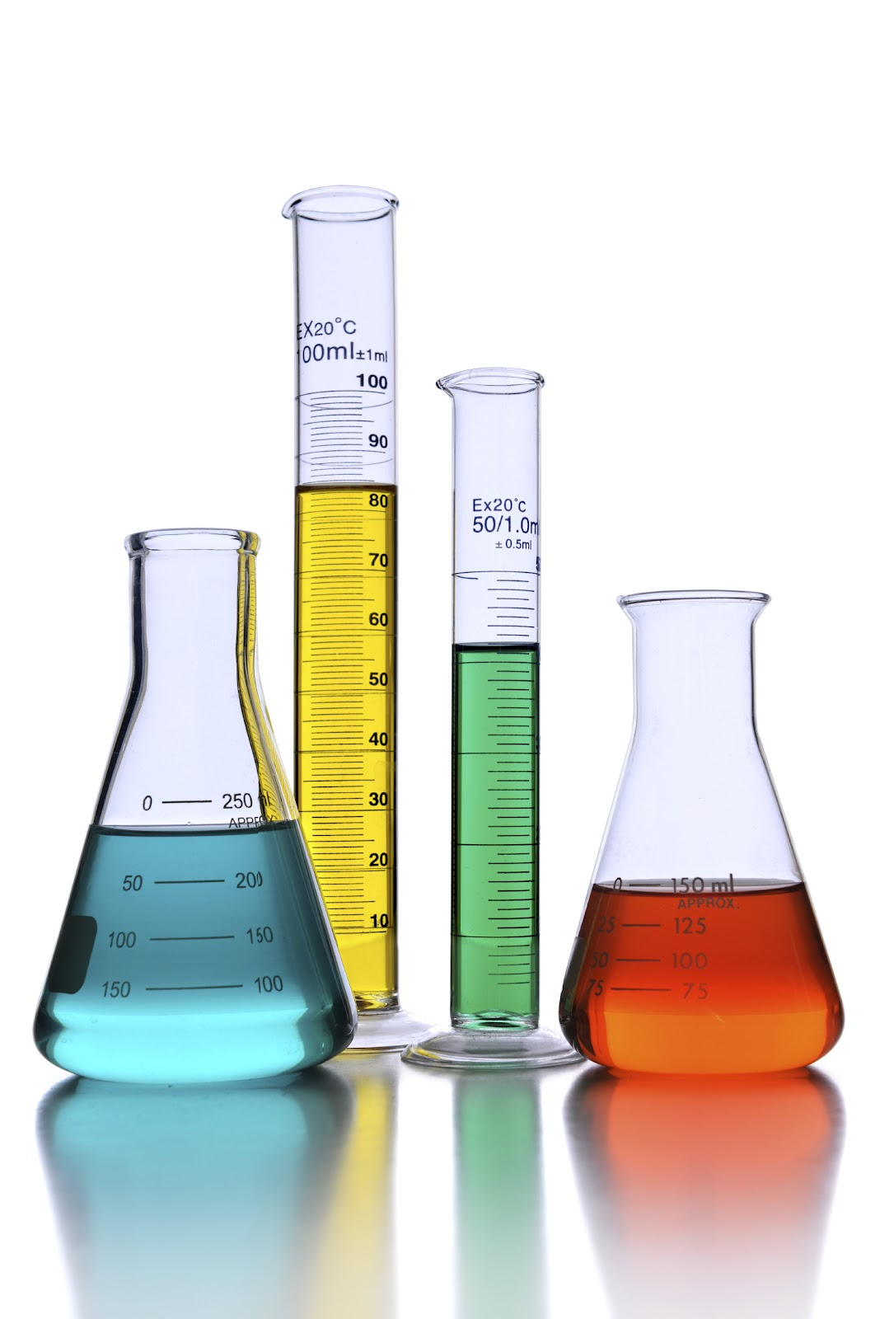
Physical Science Quiz #5 Study Guide - Solutions
Directions: Answer the following questions to help prepare for your quiz.
- What is a solution?
- Explain the difference between a solute and a solvent.
- Describe three ways you can increase the rate of dissolving.

- What is solubility?
- Explain the difference between concentrated solutions and dilute solutions.
- Explain saturated, unsaturated, and supersaturated solutions.
- Explain how pressure and temperature affect the solubility of a gas in a liquid.

- How are electrolytes different from nonelectrolytes?
- Explain the process of ionization.
- Explain the process of dissociation.
- How do solute particles affect the freezing point and the boiling point of the solvent?

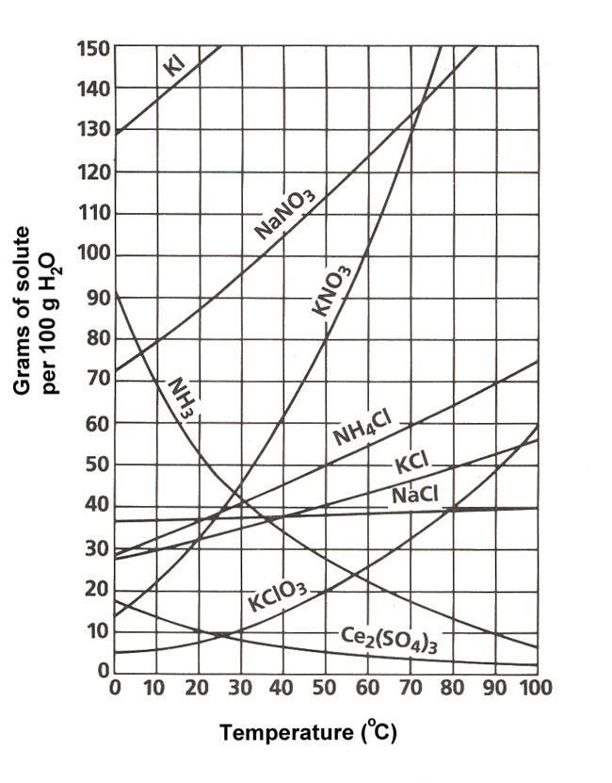
Solubility Curve

What type of solution do you have if you dissolve 20 grams of KCl into 100 grams of water at 30º C?

What type of solution do you have if you dissolve 90 grams of KNO₃ into 100 grams of water at 60º C?

Which solutes are not really affected by a change in temperature?

Give an example of a saturated solution of KClO₃?

